Lab 11

Isaiah Hoffer

LAB Q A1:

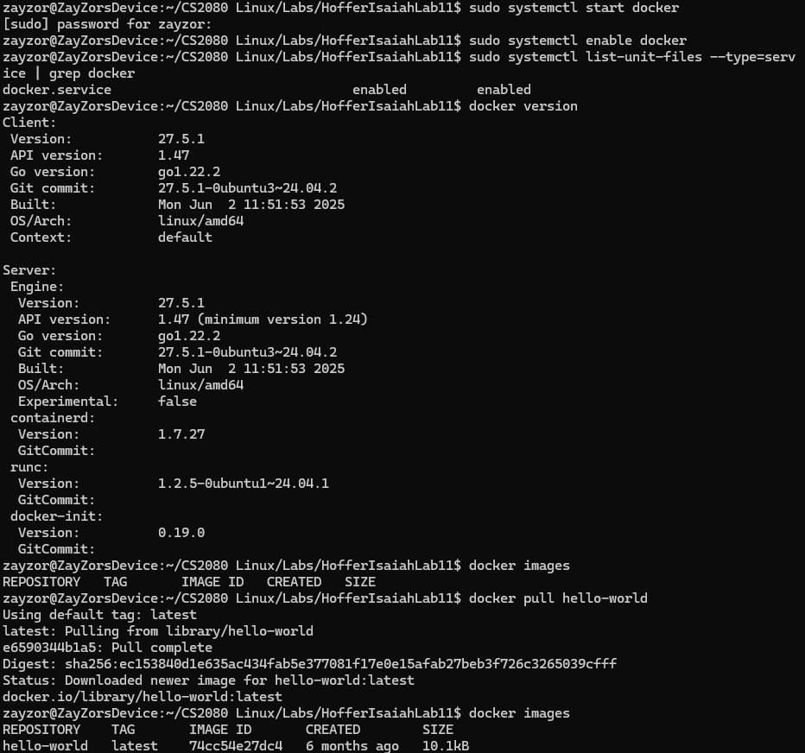

LAB Q B1:

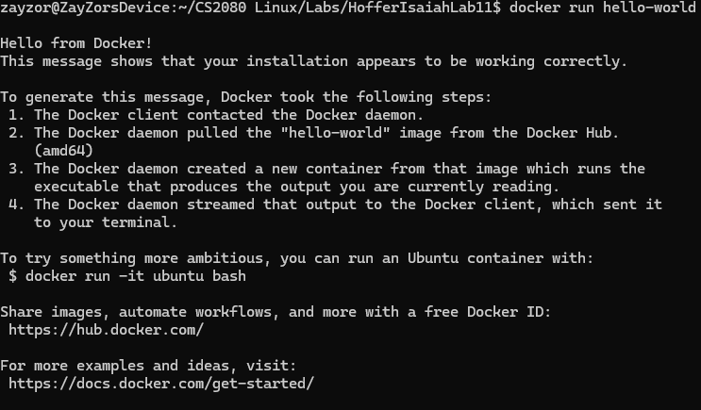

LAB Q B2:

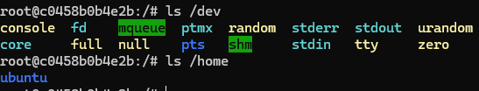

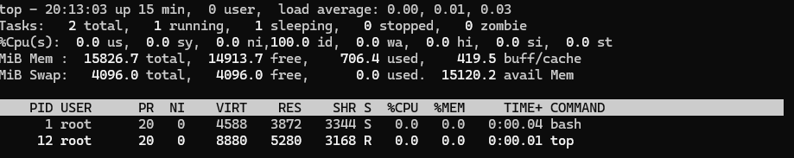

LAB Q B3:

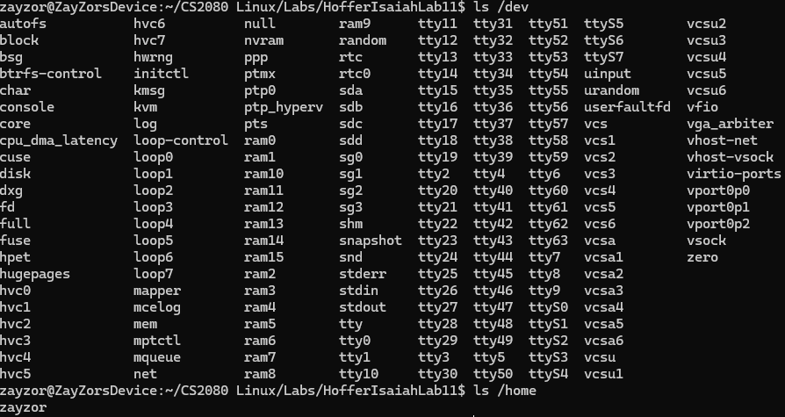

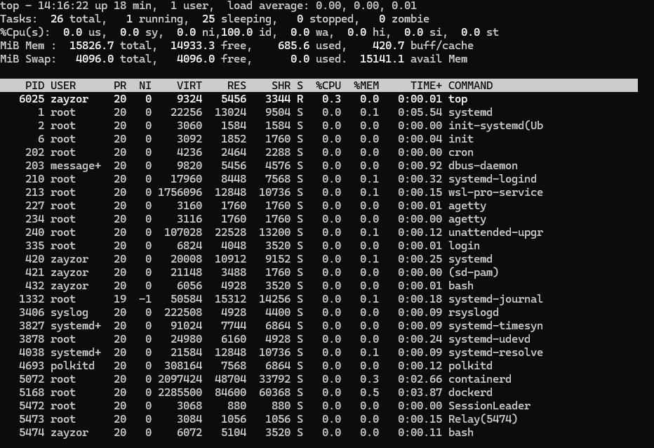

LAB Q B4:

The commands differ inside and outside the container because when you are inside, it only has the ubuntu files and processes, while outside it is reading all files and processes the VM has.

LAB Q B5:



LAB Q BC1:

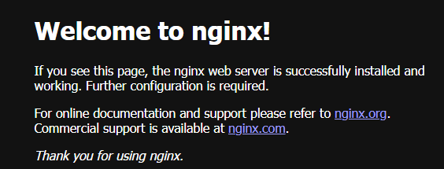

LAB Q D1:

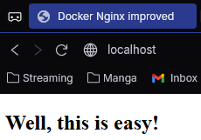

LAB Q D2:

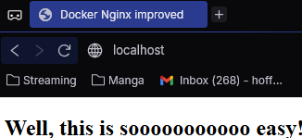

LAB Q E1:

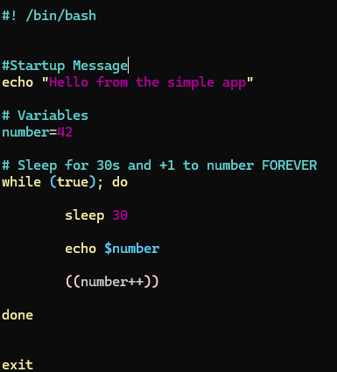

LAB Q E2:

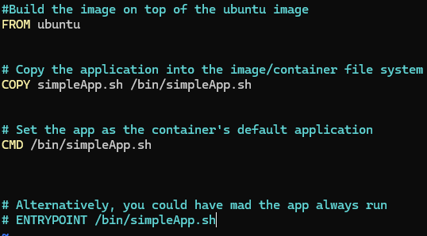

LAB Q E3:

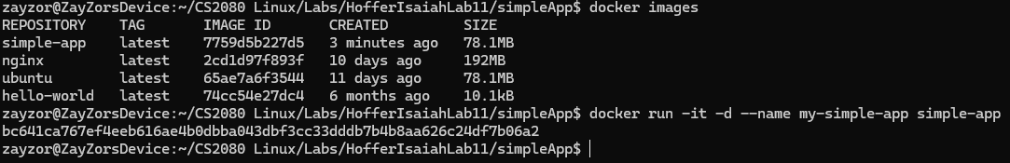

LAB Q E4:



LAB Q E5:

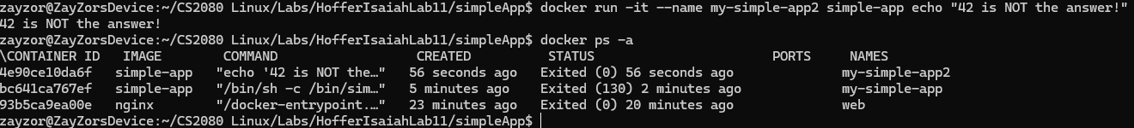

It stopped because the command given this time was echo “42 is NOT the answer” instead of CMD simpleApp.sh

LAB Q F1:

docker run -it -d --name simple-app-vol -v "/home/zayzor/CS2080 Linux/Labs/HofferIsaiahLab11/simpleApp":/var simple-app-vol

LAB Q F2:

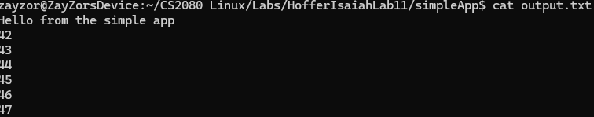

LAB Q G1:

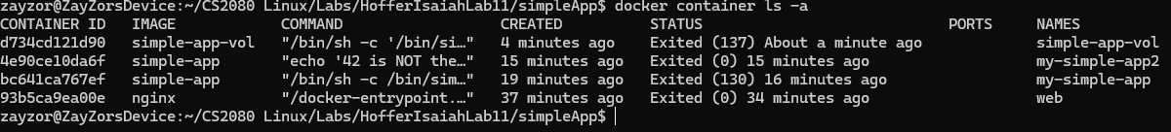

LAB Q G2:

